**JOB APPLICATION TRACKING SYSTEM**

INTRODUCTION:

OVER VIEW:

Tracking application means any software program whose primary purpose is to track or movement of an individual .An application tracking system is software for recruiters and employers to track candidates throughout the recruiting and hiring process. This software can come equipped with capabailities ranging from simple database functionality to a full any size to filter manage and analyze candidates.

PURPOSE :

Organization create job requisition because they have identified a critical business need that current staffing levels do not address the job description must translate this business need into core responsibilities. But it must also capture the attention of the most qualified candidate. An ATS has keyword- rich template for job descriptions that attract the right attention at the right time and in the places where top candidate are looking. PROBLEM DEFINITION AND DESIGN THINKING

EMPATHY MAP

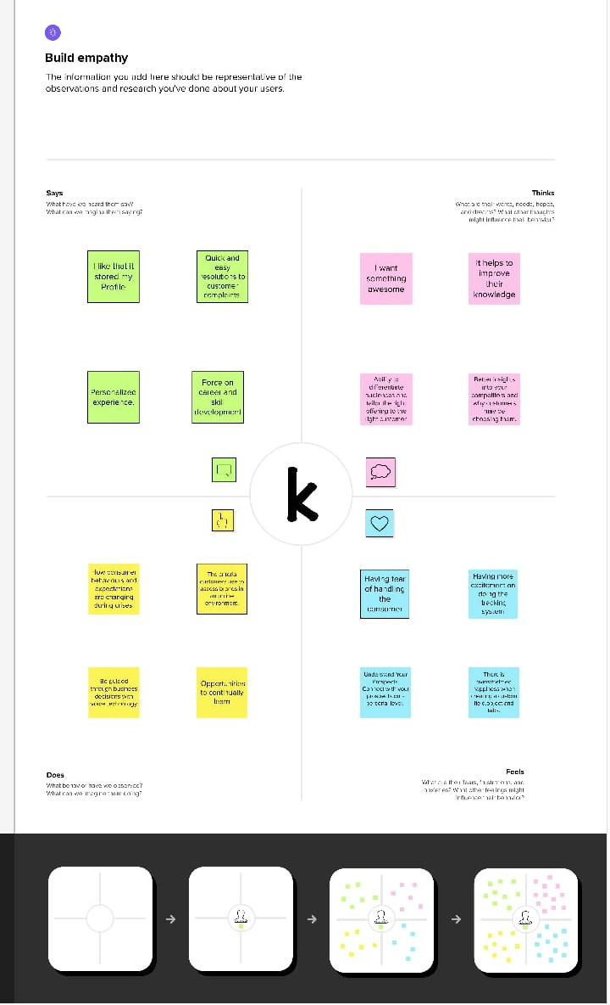

IDEATION AND BRAINSTORING MAP

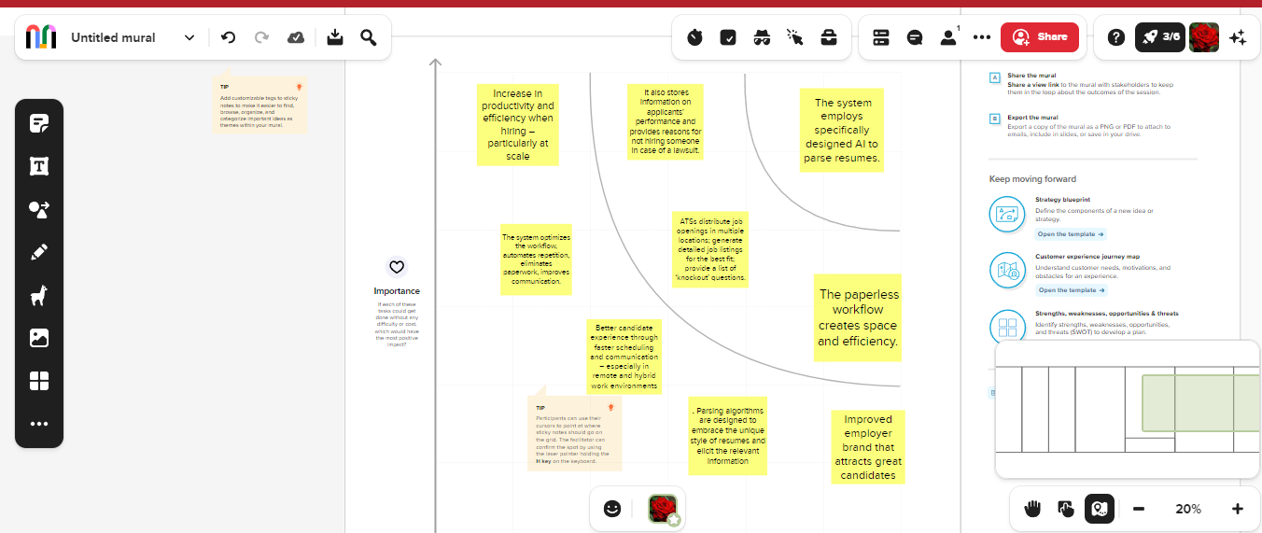

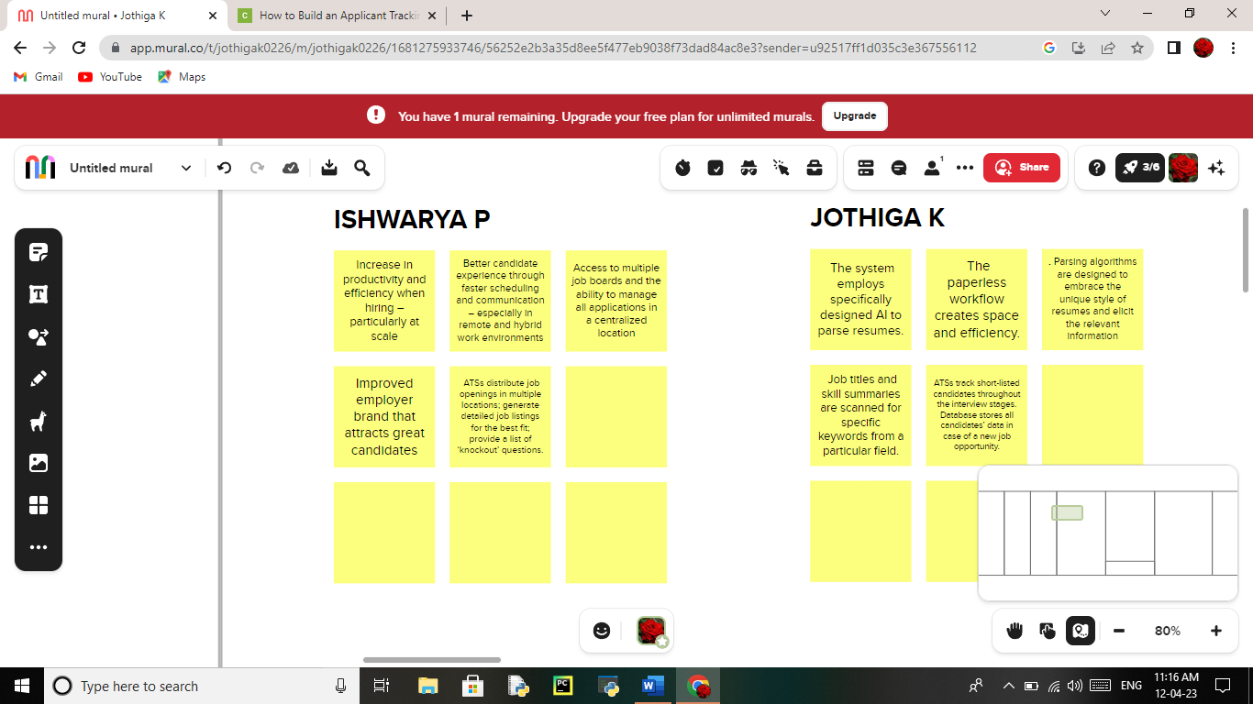

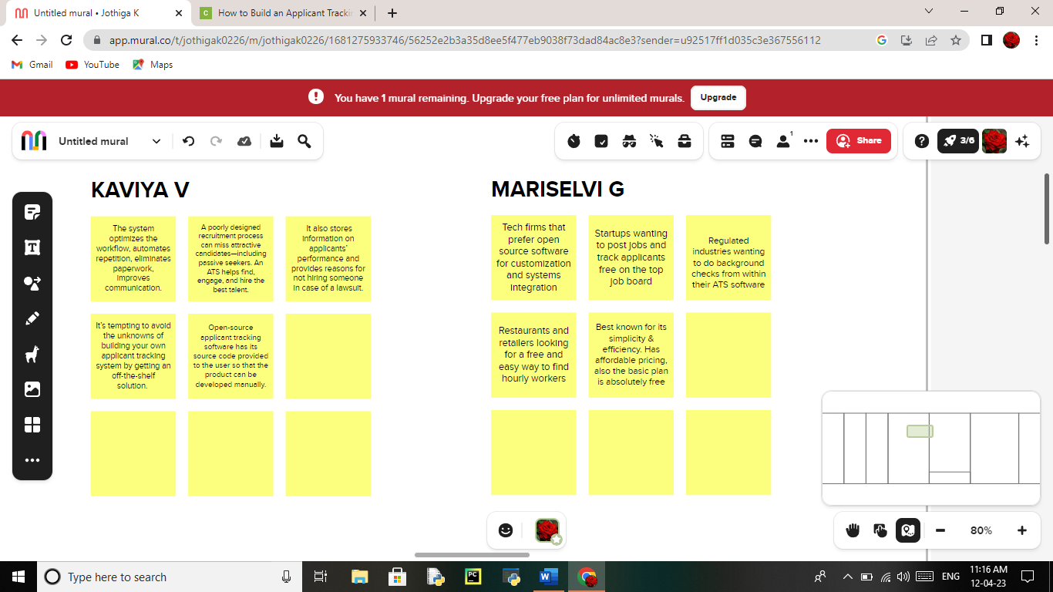

RESULT

|  |  |
| --- | --- |
| FIELD NAME | FILED AND RELATIONSHIP |
| JOB TITLE | FIELD LABEL:  JOB TITLE  DATA TYPE:  TEXT |
| RECRUITER | FIELD LABEL:  RECRUITER  DATA TYPE:  MASTER-DETAIL RELATIONSHIP |
| DESCRIPTION | FIELD LABEL:  DESCRIPTION  DATA TYPE:  TEXT AREA |
| LOCATION | FIELD LABEL:  LOCATION  DATA TYPE:  TEXT |

ACTIVITY AND SCREENSHOT

CREATING A SALESFORCE DEVELOPER ORG:

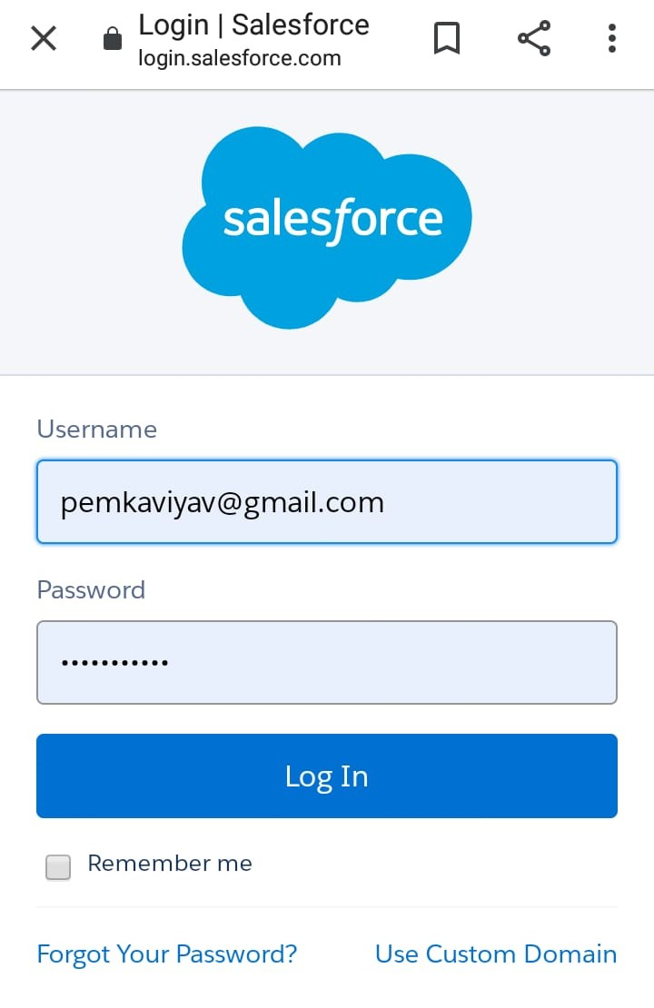

We have created an developer account for salesforce account. Salesforce is your customer success platform. Our mail.id and name are given to get developer.

CUSTOM OBJECT:

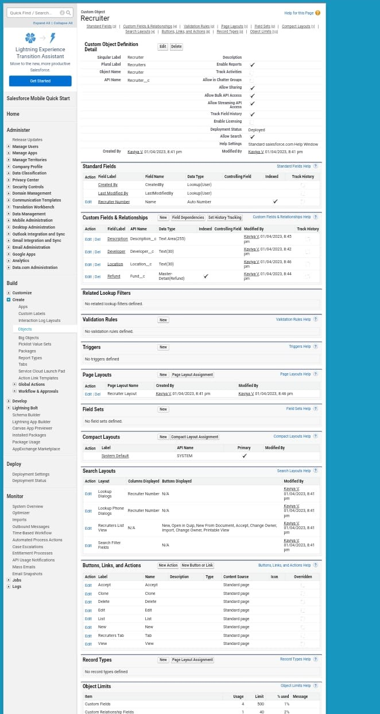

Custom object are those object that are created by users. They supply information that is unique and essential to their organization. They are that heart of any application and provide a structure for sharing data.

CUSTOM FIELDS



We have creating a Custom fields with different data type ,field label, field name and length .And we have click next .Select some profiles what we have want to show in pages. Click Save.

TABS:

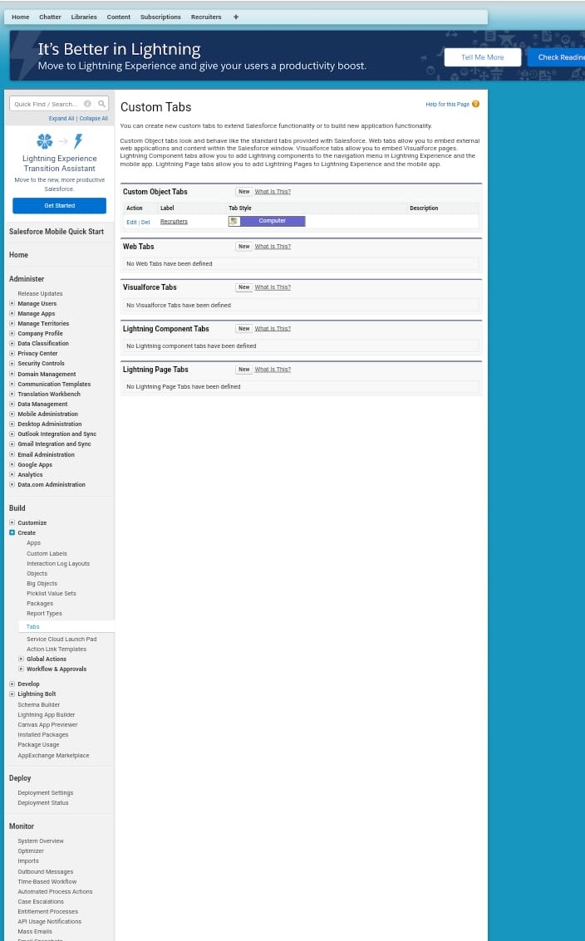

Tabs can also be used to access custom objects an custom pages. They are typically located at the top of the screen and can be customized to fit the needs of the organization.

PROFILES:

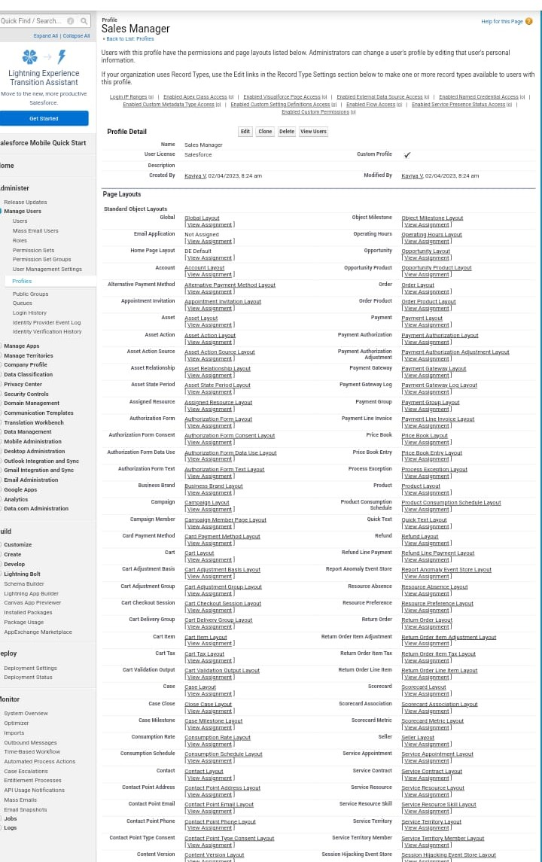

A Profile is a group/collection of settings and permissions that define what a user can do in salesforce . A profile controls “Object permissions”, Field permissions, User permissions, App settings, Apex class access, Visualforce page access , Page layouts, RECORD types, Login hours and Login IP ranges.

USER:

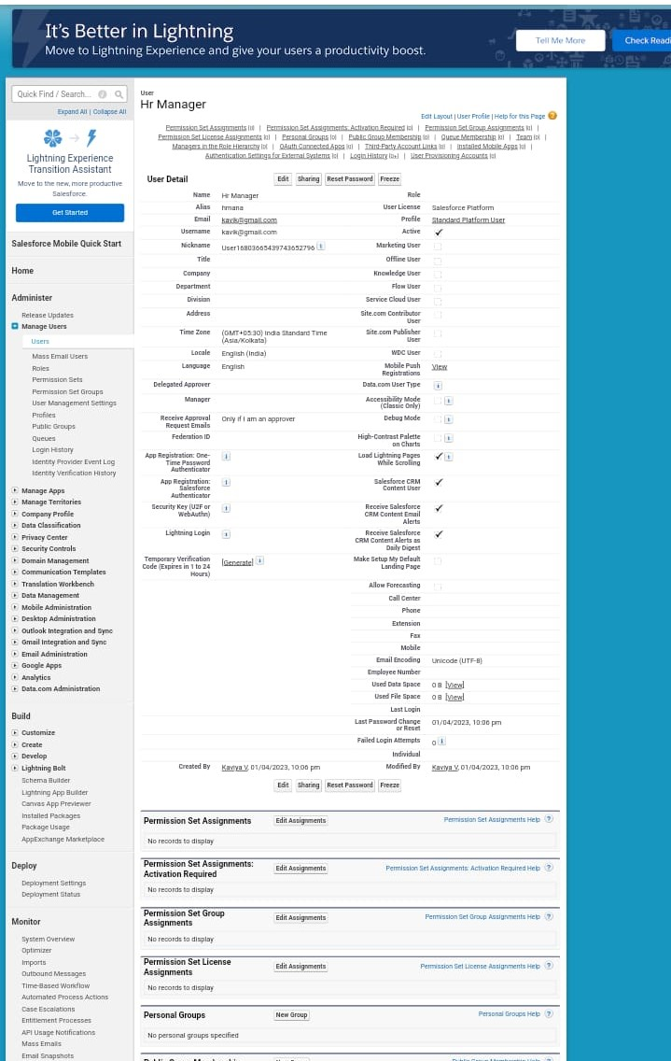

A user is anyone who logs into Salesforce. Users are employees at your company, such as sale reps, managers, and IT specialist, who need access to the company’s records. Every user in Salesforce ha a user account.

SHARING RULES:

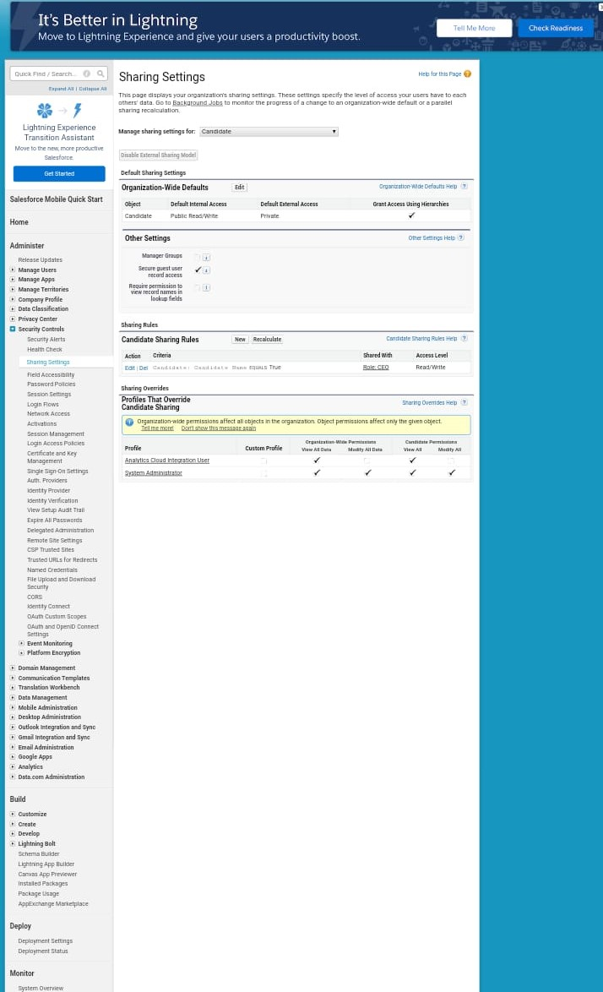

Sharing rules help users to share records based on condition. It is basically created for objects whose organization wide defaults are set to public read-only or private because sharing rules can only extend the access and not restricted it.

REPORTS:

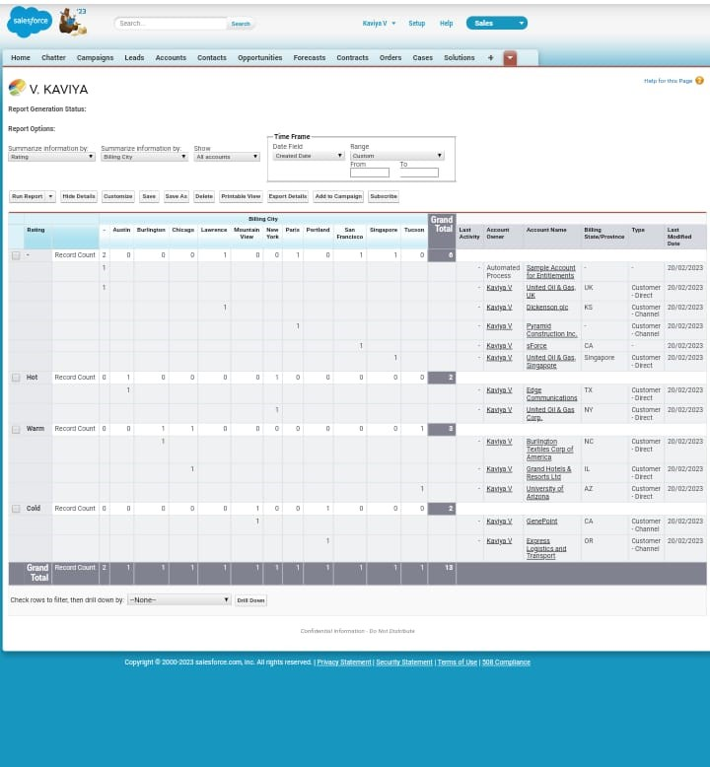

A report is a list of records that meet the criteria you define. It’s displayed in rows and columns and can be filtered, grouped or displayed in a graphical chart. Every reports is stored in a folder.

TRAILHEAD PROFILE PUBLIC URL

Team Leader- <https://trailblazer.me/id/ishwp3>

Team Member 1- <https://trailblazer.me/id/jkrishnan25>

Team Member 2- <https://trailblazer.me/id/kaviya03>

Team Member 3-https://trailblazer.me/id/marig44

ADVANTAGES:

Streamlined recruiting. Growing business often endup recruiting for multiple position at the same time.

Post jobs on multiple job boards.

Saves time by automating mundane tasks.

Build your brand.

Manages talent database.

DISADVANTAGES:

A Disadvantages of ATS is missing qualified applicants due to wrong key word selections.

Automatic elimination of resumes that software cannot recognize and interpret is another drawback of ATS.

An Applicant Tracking System Diadvantages is that they are open to manipulations.

APPLICATIONS:

Stores job candidates information like resumes, cover letters, references and other recruitment and hiring data that HR teams can easily access and organize.

Tracks job candidates and their application status throughout the hiring pipelines.

Only those on the shortlist are moved to the next stage of the hiring process.

Valuable merits and reports to improve the hiring process.

CONCLUSION:

Applcant Tracking System for recruiters is a very effective hiring solution that most of the successful recruiters utilize. Because without it ,there is a good chance that your process of moving applicants through different stages can become very difficult.

FUTURE SCOPE:

1. Candidate sourcing helping recruiters identify the most suitable job applicant is among the essential objectives of every ATS.
2. Career pages.
3. Reports analytics and KPI tracking.
4. Social media integration.
5. Centralized dashboards .
6. CRM.
7. Time management tools.
8. AI recommendations.